**D.SARATH BABU-192311031**

**EXP NO 06 :**

**CREATE A SIMPLE CLOUD SOFTWARE APPLICATION FOR PRODUCT SELLING USING ANY CLOUD SERVICE PROVIDER TO DEMONSTRATE SOFTWARE AS A SERVICE (SAAS).**

**AIM:**

To create a simple cloud software application for product selling using any cloud service provider to demonstrate saas.

**PROCEDURE: step1:** Go to zoho.com. **step 2:** Log into the zoho.com. **step 3:** Select one application step. **step4:** Enter application name as product selling. **step 5:** Created new application as product selling.

**step 6:** Select one form **step 7:** The software has been created.

**IMPLEMENTATION:**

**STEP1: GOTO ZOHO.COM**

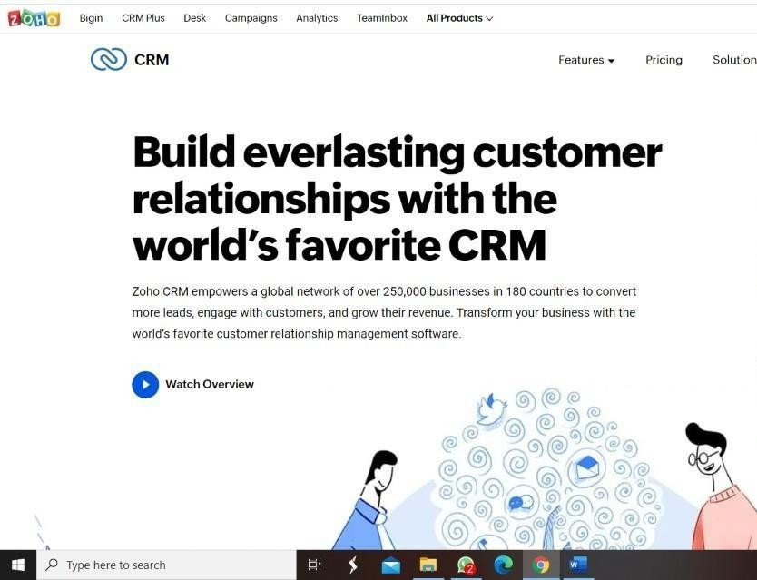

**STEP 2: LOGIN TO THE ZOHO.COM**



**STEP 3: SELECT ONE APPLICATION**

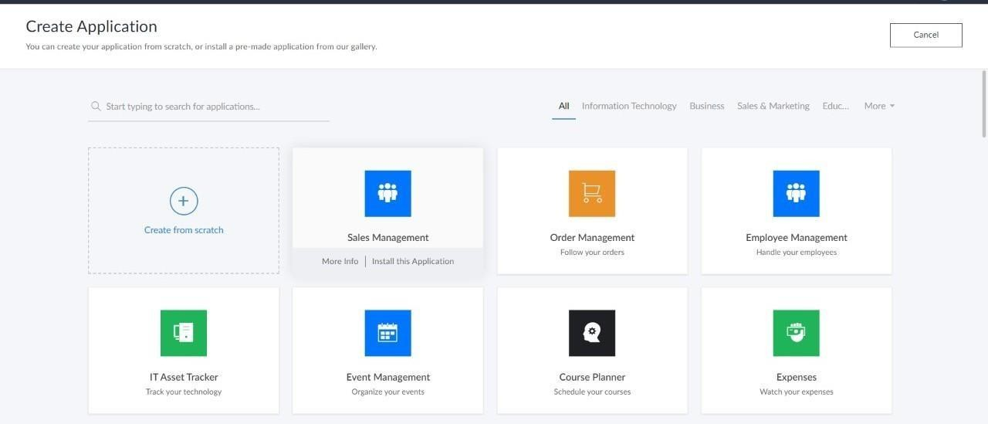

**STEP 4: ENTER APPLICATION NAME**

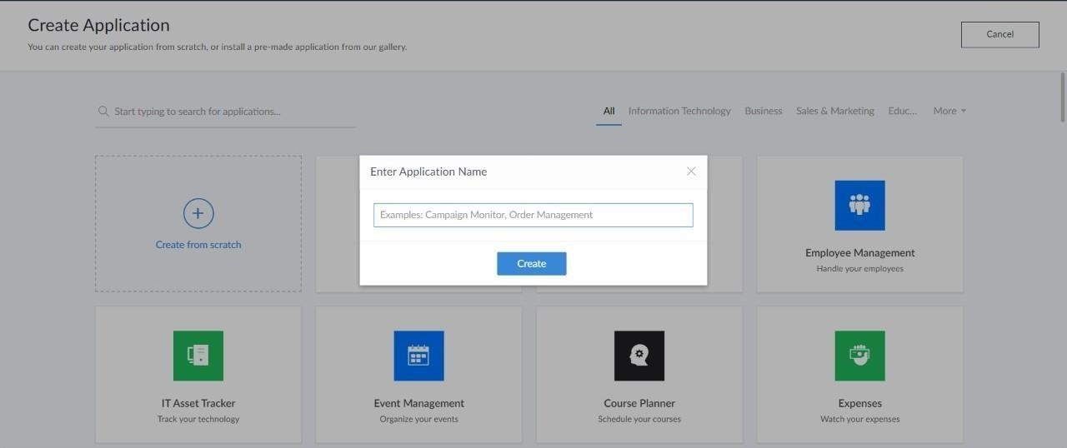

**STEP 5: CREATED NEW APPLICATION**

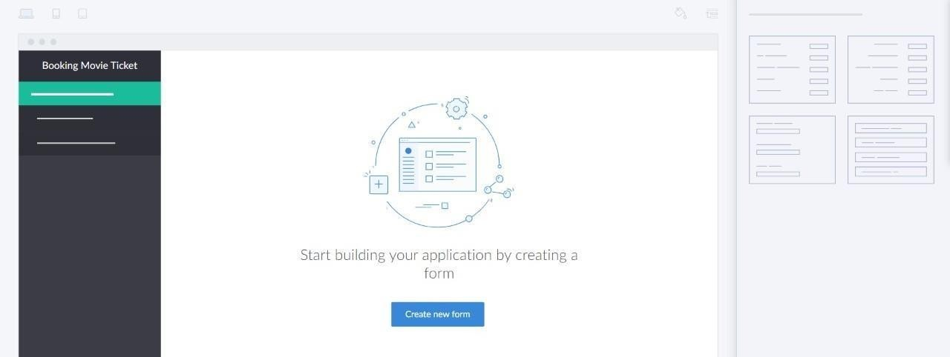

**STEP 6: SELECT ONE FORM**

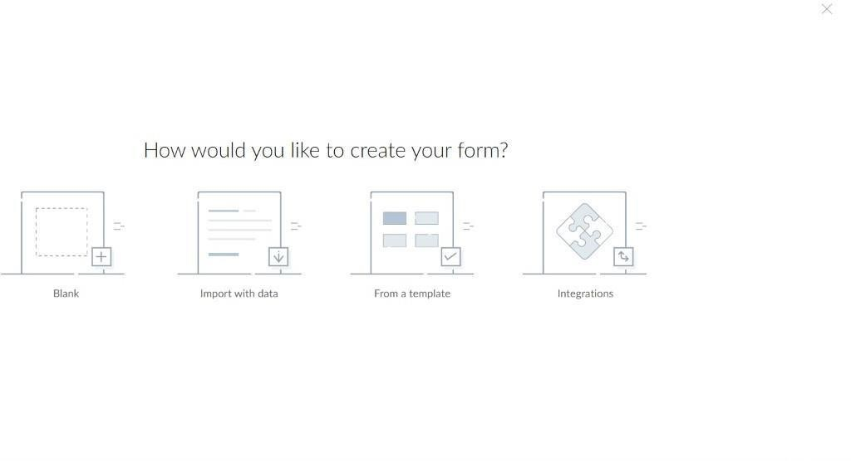

**STEP 7: THE SOFTWARE HASE BEEN CREATED.**

